def display_menu():
print("Here is our menu:")
print("")
print("1. Fried Chicken Combo - $800")
print("2. Stew Beef Combo - $900")
print("3. Jerk Pork Combo - $950")
print("4. Ting Soda - $200")
print("5. Ginger Beer Soda - $150")
print("")

def get_user_selection():
try:
choice = int(input("Please enter the number of the item you would like: "))
if 1 <= choice <= 5:
return choice
else:
print("Oops! Please enter a number from 1 to 5.")
return get_user_selection()
except ValueError:
print("Oops! Please enter a NUMBER.")
return get_user_selection()

def calculate_total_price(selected_items):
prices = [800, 900, 950, 250, 200]
total_price = sum(prices[item - 1] for item in selected_items)
return total_price

def main():
selected_items = []

while True:
display_menu()
user_choice = get_user_selection()
selected_items.append(user_choice)
print("Item added to your order!\n")

add_more = input("Would you like to add something else to your order? (Enter 'yes' or 'no'): ").lower()
if add_more == 'no':
break

print("\nYour selected items:")
for item in selected_items:
if item == 1:
print("Fried Chicken Combo - $800")
elif item == 2:
print("Stew Beef Combo - $900")
elif item == 3:
print("Jerk Pork Combo - $950")
elif item == 4:
print("Ting Soda - $200")
elif item == 5:
print("Ginger Beer Soda - $150")

total_price = calculate_total_price(selected_items)
print(f"\nYour order total is: ${total_price}")
print ("\nThank you for ordering!")

if __name__ == "__main__":
print("Welcome to Shaggy's Cookshop!")
main()

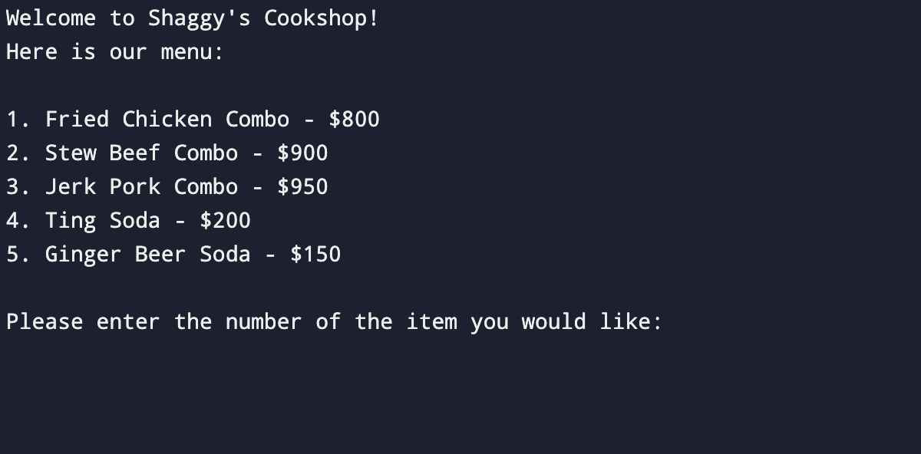
Screenshots of Working Code

Figure 1: Program welcome screen to Shaggy’s Cookshop
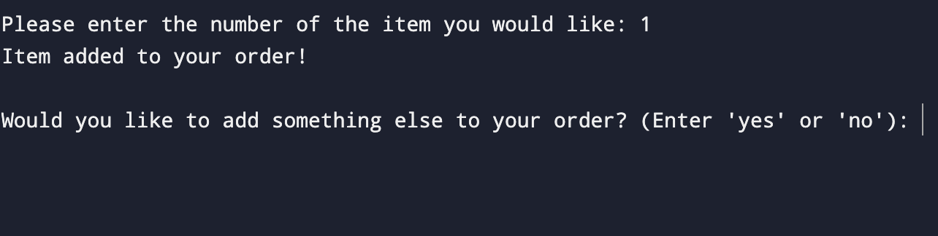

Figure 2: Prompt after entering first selection that asks the user if they would like to add another item to their order
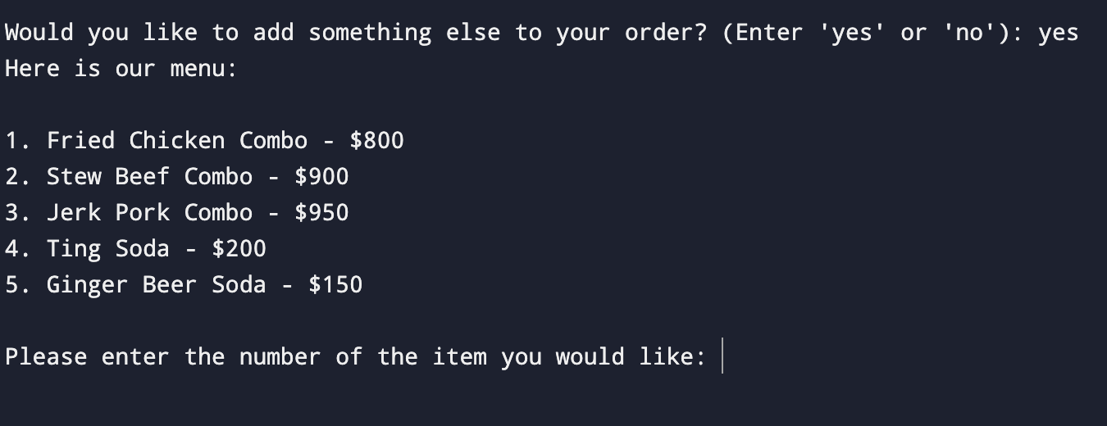

Figure 3: The menu is re-displayed if ‘yes’ is selected, allowing user to enter another selection

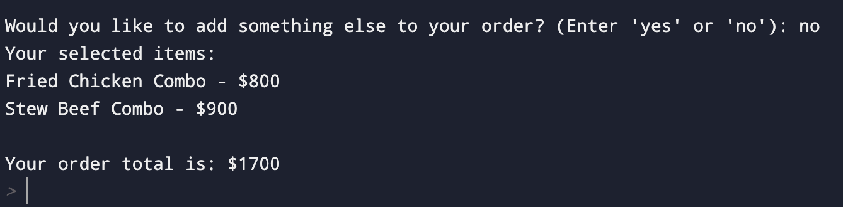

Figure 4: If the user does not want to add anything else to their order and ‘no’ is entered, their order items and total are displayed
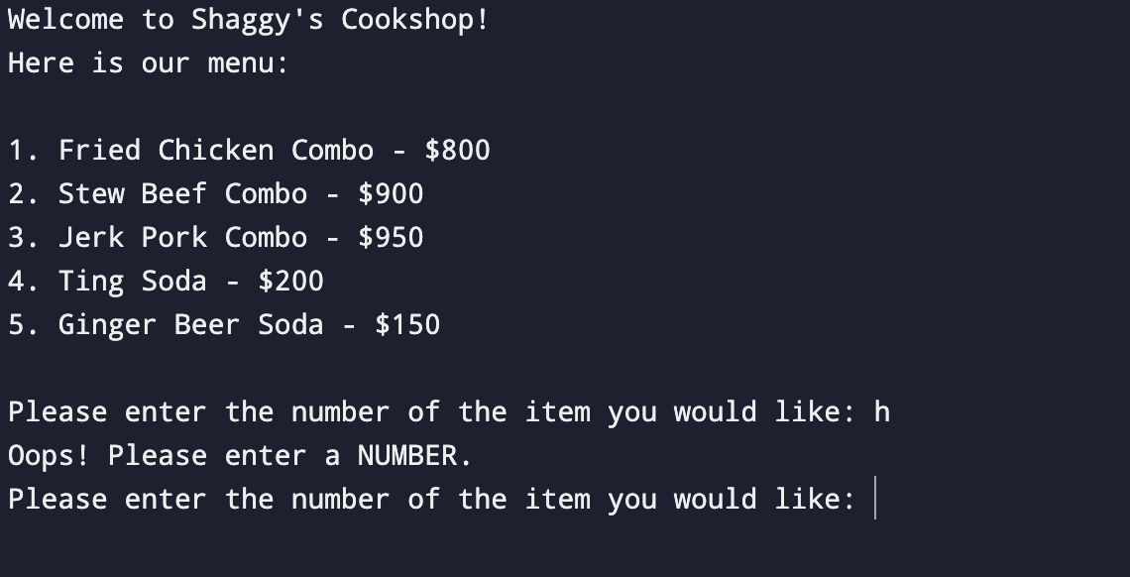

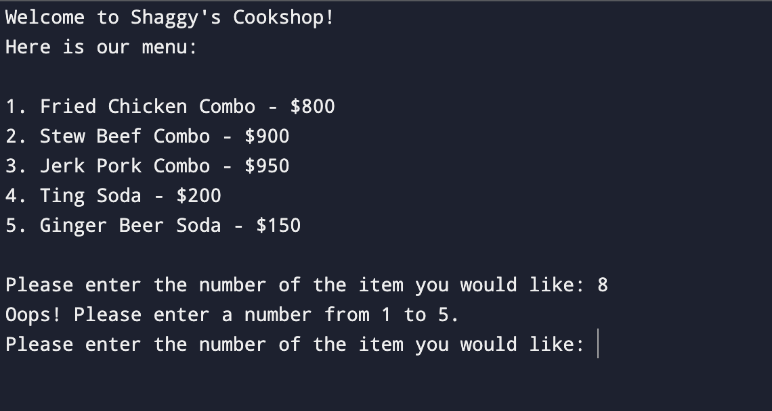
Figure 5: After the welcome screen is displayed, if the user’s entry is not an integer an error message is displayed and they are re-prompted to enter their selection

Figure 6: After the welcome screen is displayed, if the user’s entry is not equal to an integer from 1 to 5, an error message is displayed and they are re-prompted to enter their selection
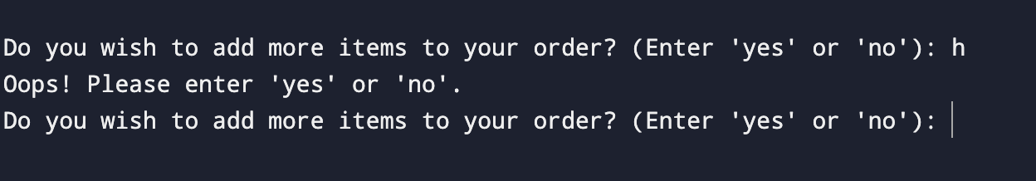

Figure 7: If a value other than ‘yes’ or ‘no’ is entered then an error message is displayed and the user is re-prompted to enter ‘yes’ or ‘no’.

